**K-nearest neighbors algorithm**

**#Importing Packages**

import pandas as pd

from sklearn import preprocessing

from sklearn.model_selection import train_test_split

from sklearn.metrics import accuracy_score

from sklearn.metrics import confusion_matrix

from sklearn import neighbors

from sklearn import svm

**#Loading dataset**

dataset=pd.read_csv(“train.csv”)

**#Converting text into numerical**

le=preprocessing.LabelEncoder()

le.fit(dataset[“Sex”])

Out[8]: LabelEncoder()

print(le.classes_)

[‘female’ ‘male’]

**dataset[“Sex”] = le.transform(dataset[“Sex”])**

**dataset[“Embarked”] = le.fit_transform(dataset[“Embarked”])**

**#Implementation of KNN**

y=dataset[“Pclass”]

X=dataset.drop([“Pclass”, “PassengerId”,”Name”, “Cabin”, “Ticket”],axis=1)

X.head()

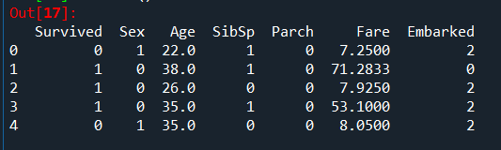

**x_train, x_test, y_train, y_test = train_test_split(X, y, test_size = 0.3, random_state = 0)**

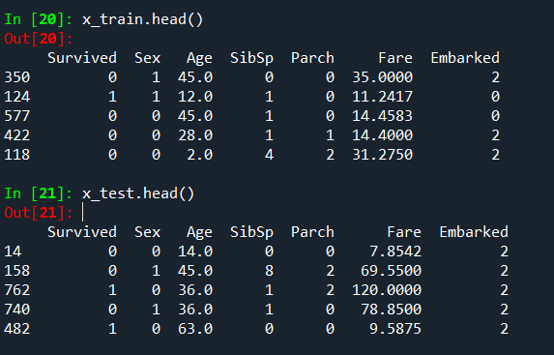

def KNNA(k,X,y):

knn=neighbors.KneighborsClassifier(n_neighbors=k)

score = knn.fit(x_train, y_train).score(x_test,y_test)

y_pred = knn.predict(x_test)

return score

for I in range(1,268):

score_now=KNNA(I,X,y)

if(k_val==0):

k_val=i

acc_score=score_now

if(score_now>acc_score):

k_val=i

acc_score=score_now

knn = neighbors.KneighborsClassifier(n_neighbors=k_val)

y_pred = knn.fit(x_train,y_train).predict(x_test)

c_matrix = confusion_matrix(y_test,y_pred)

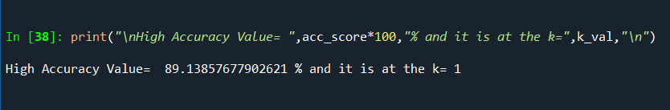

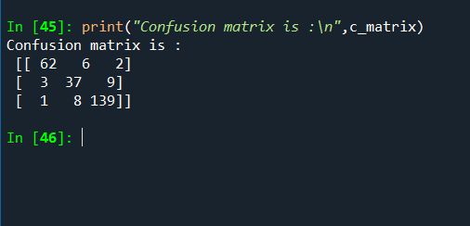

**Supoort Vector Machine**

clff = svm.SVC(gamma=0.01,C=100)

def Svm(X,y):

X_train,X_test,y_train,y_test = train_test_split(X,y,test_size=0.3,random_state = 0)

y_pred = clff.fit(X_train,y_train).predict(X_test)

acc_score = accuracy_score(y_test,y_pred,normalize=True)

conf_mat = confusion_matrix(y_test,y_pred)

return acc_score,conf_mat

depVars = ['Survived','Pclass','SibSp','Sex','Parch','Embarked']

for i in depVars:

print(" ",i," vs Remaining:")

y = dataset[i]

X = dataset.drop(i,axis=1)

Score,Matrix = Svm(X,y)

print("Accuracy Score for", i ,"vs Remaining = ",Score*100,"%\n")

print("Confusion Matrix is :-")

print(Matrix,"\n\n")

